Supplementary Information

Chronological validation of cell-level aging and loaded voltage-SOC consistency for evidence-controlled lithium-ion endurance analysis
Leqi Hong^{a,†}, Jiachen Han^{a,†}, Qingjie Guo^{a,}*
ª Leicester International Institute, Dalian University of Technology, Panjin, 124221, China
*Corresponding author: Qingjie Guo (qjguo@dlut.edu.cn)
†These authors contributed equally: Leqi Hong and Jiachen Han.

Table of Contents
1. Supplementary Data Processing and Methods S1
1.1 CALCE cycle extraction details S1
1.2 GreenHub field-log processing statistics S1
1.3 Influencing-factor reduction and model limitations............................................................S2
1.4 Bootstrap implementation details..........................................................................................S2
2. Supplementary Evaluation Metrics S4
2.1 Voltage reconstruction errors across SOC regions S4
3. Supplementary Sensitivity Analyses S5
3.1 Complementary laboratory and field characteristics S5
3.2 Capacity derived endurance sensitivity S6
4. Supplementary Tables S7
5. Supplementary Figures S9
6.Supplementary references S10

- Supplementary Data Processing and Methods
1.1 CALCE cycle extraction details
The CS2-21 battery is a graphite LiCoO2 portable cell rated at 1100 mAh. Valid discharge cycles were retained based on a discharge count greater than zero and a measured current less than negative 100 mA. Each cycle must contain at least 80 samples and last at least 1.5 hours. The discharge capacity must reach at least 80 percent of the recorded value. The time stamp must be strictly incremental. The sampling gap must not exceed 5 minutes or five times the median interval.

1.2 GreenHub field-log processing statistics
GreenHub observations were filtered based on strict elapsed time and battery level decline criteria. Valid intervals were restricted to elapsed times between 30 seconds and 2 hours. The battery level must decrease by 1 to 15 percentage points. The inferred decline rate must fall between 0.2 and 40 percentage points per hour. A new session started after charging or a gap exceeding 2 hours. Valid intervals were aggregated at the device session hour level. The final dataset contains 103100 valid intervals aggregated into 30873 device session hour units across 11874 sessions.

1.3 Influencing-factor reduction and model limitations
The discharge endpoint is influenced by multiple factors including ambient temperature, discharge rate, discharge depth, average charge state, and potential degradation mechanisms. This study adopts a simplified model with three components. These are the aging available capacity, load-side voltage response, and time-load distribution. Temperature and discharge rate affect both capacity and voltage response (Barré et al. 2013; Dubarry et al. 2011; Saxena et al. 2016). Discharge depth and average state of charge influence long-term capacity evolution (Dubarry et al. 2011; Saxena et al. 2016). Resistance growth and polarization further change the discharge behavior (Birkl et al. 2017; Spotnitz 2003; Wang et al. 2023). Since existing records cannot distinguish these effects, this study does not quantify individual contributions. These components organize physical evidence rather than establish a statistical ranking of influential factors.

1.4 Bootstrap implementation details
Capacity comparison uncertainty was quantified using a paired moving block bootstrap method. The method applied 20000 resamplings to the absolute error differences. A block length of 5 accepted cycles was used. A fixed seed of 20260724 ensured reproducibility. For voltage reconstruction, 95 percent confidence intervals were obtained using a circular moving block bootstrap method. The resampling was performed 20000 times with a segment length of 5 cycles. A fixed seed of 20260806 was used. The common support interval terminates at the earliest measured or predicted endpoint.

2. Supplementary Evaluation Metrics
2.1 Voltage reconstruction errors across SOC regions
Within the primary common support interval the voltage errors were largest in the lowest SOC region from 0.20 to 0.30. The MAE and RMSE in this region were 38.345 mV and 42.844 mV respectively. Over the SOC range of 0.30 to 0.70 the MAE and RMSE were 31.300 mV and 31.479 mV. The SOC range of 0.70 to 0.95 yielded an MAE of 32.755 mV and an RMSE of 34.906 mV. The similar magnitudes of the absolute bias and MAE indicate that the confirmatory error was dominated by systematic voltage underprediction rather than scatter of residuals centered around zero.

3. Supplementary Sensitivity Analyses
3.1 Complementary laboratory and field characteristics
This section provides the complementary characteristics of the controlled laboratory cell data and the smartphone field observations. The normalized discharge trajectories from CALCE exhibit highly consistent shapes across cycles. This consistency supports the use of a controlled discharge profile. The GreenHub observations reveal a broad hourly distribution of battery level decline. Screen on states generally show higher decline rates than screen off states. However screen activation often coincides with simultaneous demand from the processor and network. Therefore this separation is purely observational. Furthermore these field observations cannot be directly interpreted as absolute cell level power. Ultimately these two sources serve complementary roles. CALCE provides controlled electrical characterization while GreenHub provides field timing sensitivity.

3.2 Capacity derived endurance sensitivity
The model-based sensitivity of capacity-derived endurance to initial SOC is shown in Figure S2. Increasing the initial SOC from 0.30 to 1.00 extends the endurance distribution toward longer runtime due to the larger charge inventory. A matched demand analysis further examined the effect of temporal workload organization. By fixing the initial SOC at 0.80 and maintaining constant cumulative depletion, the median endurance values reached 6.68 h for the constant profile, 7.11 h for the piecewise profile, and 6.88 h for the continuous profile. This controlled sensitivity test confirms that redistributing cumulative depletion over time alters endurance estimates under the adopted first-passage framework. These observations align with prior reports that aging trajectories diverge even among nominally identical cells (Kosch et al. 2017; Rüther et al. 2023). Furthermore, transferring cell-specific relations across batteries without recalibration inflates prediction error (Strange et al. 2022; Wildfeuer and Lienkamp 2021). Future work should extend this single-series design to multi-cell datasets and broader operating conditions. Coupling capacity-aging with uncertainty-aware prediction will also be essential before any population-level claim can be made (Richardson et al. 2019; Zhang et al. 2019).

- Supplementary Tables

Table S1 Data sources, processing roles, and admissible claims.

Source | Information used | Role in the framework | Claim boundary
CALCE CS2-21 | Current, voltage, cycle index, integrated capacity | Primary chronological capacity evaluation and terminal-voltage reconstruction | Primary controlled-cell evidence
CALCE CS2-8 | Current, voltage, cycle index, capacity to 3.0-V analysis endpoint | Independent-cell chronological replication of terminal-voltage reconstruction | Same-series replication, cell-specific calibration, not zero-shot
GreenHub Farmer | Timestamped battery-level and screen-state observations | Normalized temporal workload profiles and variability | Timing proxy only, not calibrated current or power
Additional CALCE CS2-series cells | Cycle index, current, voltage, integrated capacity | Same-series capacity-model evaluation and independent voltage reconstruction | Procedural reproducibility and cell-specific accuracy

Note. The claim boundary defines the maximum interpretable scope of the data source. The term proxy indicates that field observations characterize temporal patterns rather than absolute electrical measurements. The term zero-shot refers to direct parameter transfer without any cell-specific recalibration.

Table S2 Chronological data split for CS2 series cells.
Cell | Development Cycles | Confirmatory Cycles
CS2 21 | 1 to 60 | 81 to 101
CS2 8 | 1 to 60 | 81 to 96
CS2 33 | 1 to 60 | 81 to 100
CS2 34 | 1 to 60 | 81 to 100
CS2 35 | 1 to 60 | 81 to 101
CS2 36 | 1 to 60 | 81 to 100
CS2 37 | 1 to 60 | 81 to 100
CS2 38 | 1 to 60 | 81 to 100

Note. Development cycles are used for model fitting and selection. Confirmatory cycles are withheld for final evaluation. Robustness screening cycles between these sets are excluded from the reported metrics. The number of eligible confirmatory cycles varies across cells due to the availability of complete discharge records.

5. Supplementary Figures

Figure S1. Complementary characteristics of laboratory cell data and smartphone field logs. (a) Rated-capacity-normalized CALCE CS2-21 discharge trajectories and the 20 percent rated-capacity reference level. (b) Hourly GreenHub battery-level decline after device-session-hour aggregation. GreenHub decline is derived from operating-system battery-level snapshots and is not a direct electrical-power measurement. Normalization removes absolute capacity differences. Therefore the trajectories are used only to illustrate the controlled discharge shape rather than degradation magnitude.
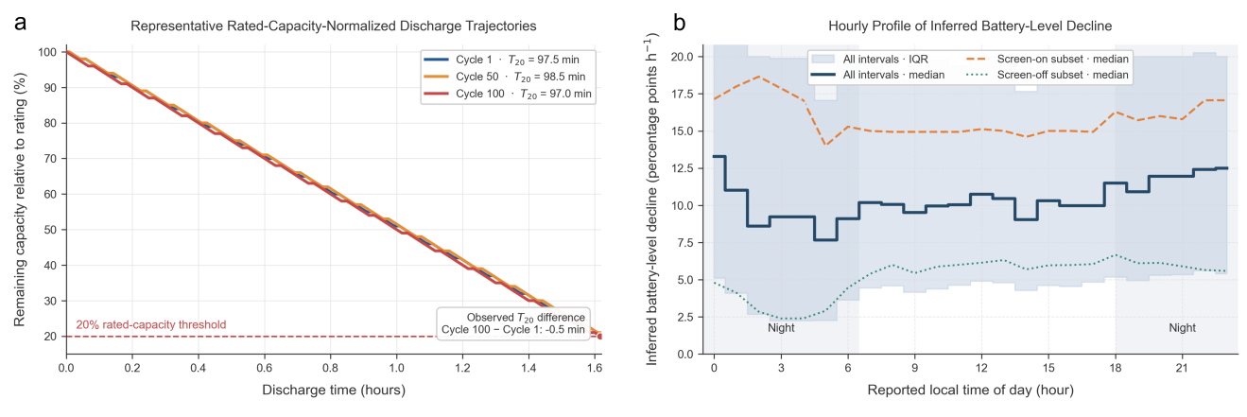

Figure S2. Model-based sensitivity of capacity-derived endurance to initial SOC under otherwise fixed simulation settings.

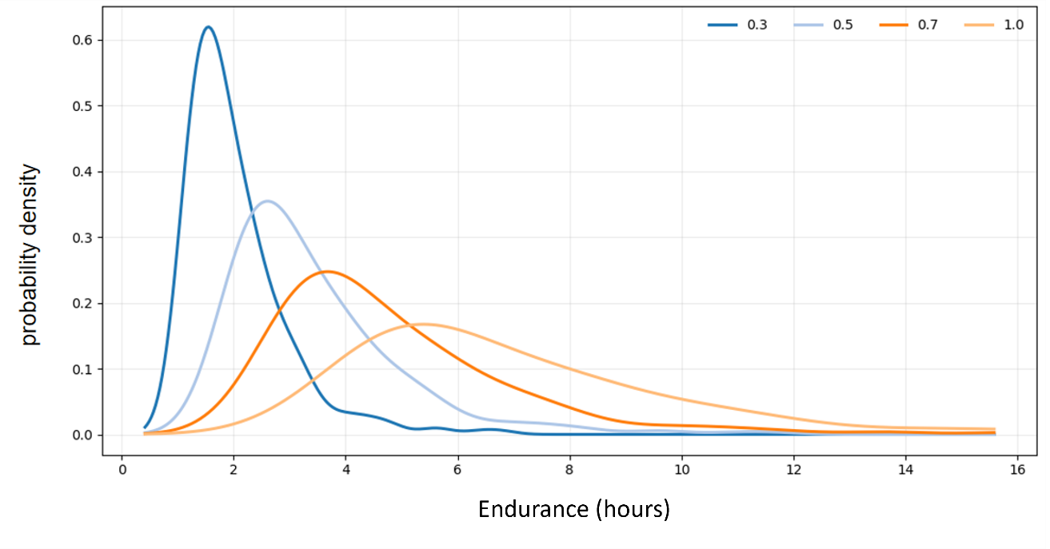
6. Supplementary references
Barré, E. V., Deguilhem, B., Grolleau, S., Gérard, M., Suard, F., and Riu, D. (2013). "A review on lithium-ion battery ageing mechanisms and estimations for automotive applications." J. Power Sources, 241, 680-689.
Birkl, C. R., Roberts, M. R., McTurk, E., Bruce, P. G., and Howey, D. A. (2017). "Degradation diagnostics for lithium ion cells." J. Power Sources, 341, 373-386.
Dubarry, M., Truchot, C., Liaw, B. Y., Gering, K., Sazhin, S., Jamison, D., and Michelbacher, C. (2011). "Evaluation of commercial lithium-ion cells based on composite positive electrode for plug-in hybrid electric vehicle applications. Part III." J. Power Sources, 196, 3437-3447.
Kosch, S., Sturm, J., Rheinfeld, A., Erhard, S., Noel, K., and Jossen, A. (2017). "Investigation of cyclic aging of lithium-ion cells at defined temperature and cell voltage." J. Energy Storage, 14, 325-334.
Richardson, R. R., Osborne, M. A., and Howey, D. A. (2019). "Battery health prediction under generalized conditions using a Gaussian process transition model." J. Energy Storage, 23, 320-328.
Rüther, T., Schamel, M., Plank, C., Schomburg, F., Röder, F., and Danzer, M. A. (2023). "Cell-to-cell variation beyond parameter analysis—identification and correlation of processes in lithium-ion batteries using a combined distribution of relaxation times analysis." J. Power Sources, 587, 233677.
Saxena, S., Hendricks, C., and Pecht, M. (2016). "Cycle life testing and modeling of graphite/LiCoO2 cells under different state of charge ranges." J. Power Sources, 327, 394-400.

Spotnitz, R. (2003). "Simulation of capacity fade in lithium-ion batteries." J. Power Sources, 113(1), 72-80.
Strange, C., Allerhand, M., Dechent, P., and dos Reis, G. (2022). "Automatic method for the estimation of li-ion degradation test sample sizes required to understand cell-to-cell variability." Energy AI, 9, 100174.
Wang, F., Tang, S., Han, X., Lu, L., Yu, C., Zhao, C., Gao, Y., Zhu, G., Zhuang, K., and Ouyang, M. (2023). "A voltage reconstruction model for lithium-ion batteries considering the polarization process." J. Power Sources, 588, 233744.
Wildfeuer, L., and Lienkamp, M. (2021). "Quantifiability of inherent cell-to-cell variations of commercial lithium-ion batteries." eTransportation, 9, 100129.
Zhang, Y., Xiong, R., He, H., and Pecht, M. G. (2019). "Lithium-ion battery remaining useful life prediction with Box-Cox transformation and Monte Carlo simulation." IEEE Trans. Ind. Electron., 66(2), 1585-1597.

